Alex Arnold
Professor Torres
2-21-25
IT 120-41198
Lab 4

Part A: NDG Security+ v3
For this lab, please follow the below instructions:
- perform a hardware inventory of all devices within this network (except the Kali box).
-Manual in an Excel spreadsheet, or scripted
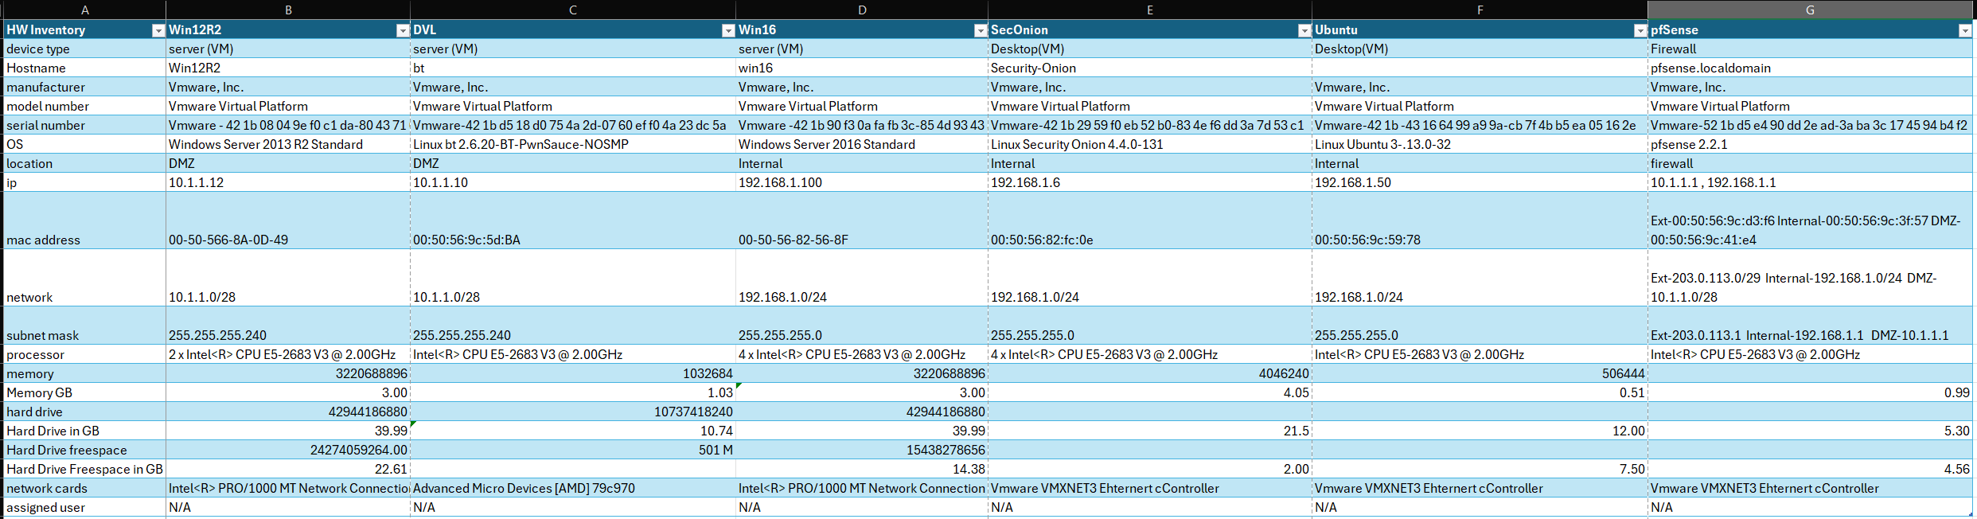
Hw log in excel (excel sheet was also turned in with this file)
- perform a software inventory of all devices within this network (except the Kali box).
-manual in an Excel spreadsheet, or scripted
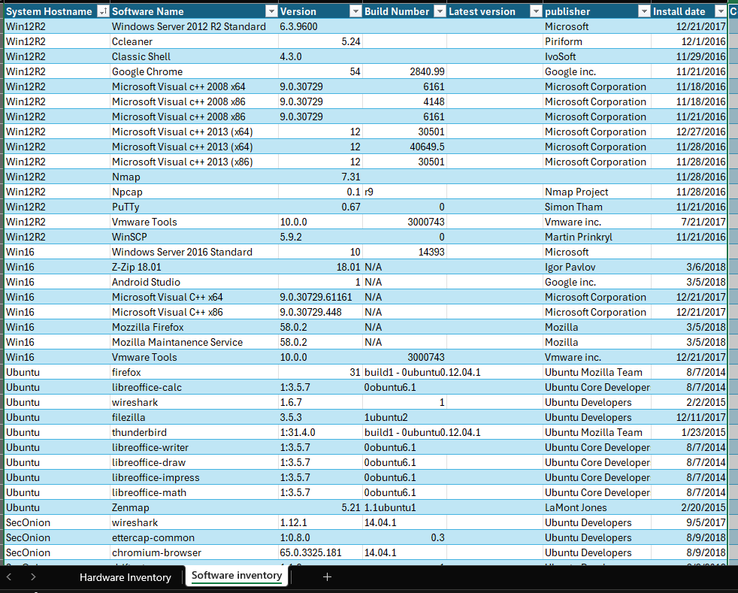
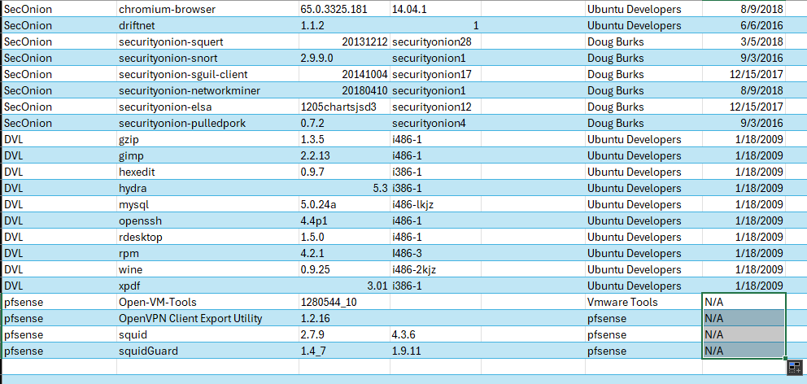
  - software inventory (excel sheet was also turned in with this file)

Part B: Home PC/Laptop
- On the computer that you are doing this lab on:
  - perform a hardware inventory (to include your bios/UEFI version)
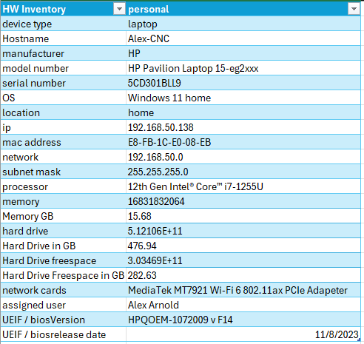
  - perform a software inventory (to include the OS)
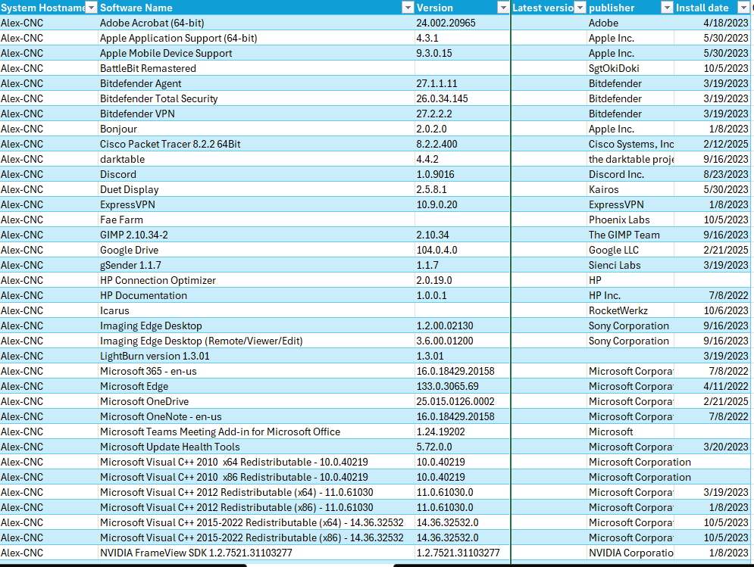
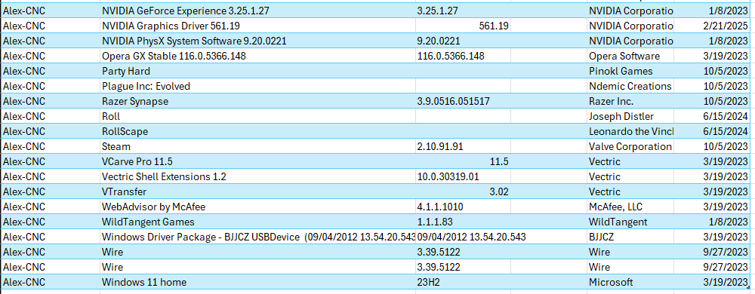
Part C: For both parts A and B
- Research if the software is the most current version (list the most current)

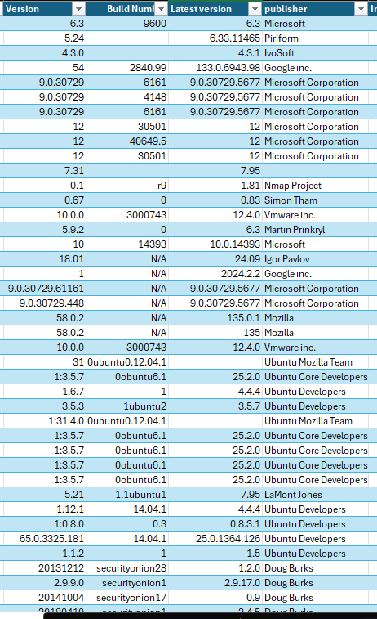
Versions for the netlab systems

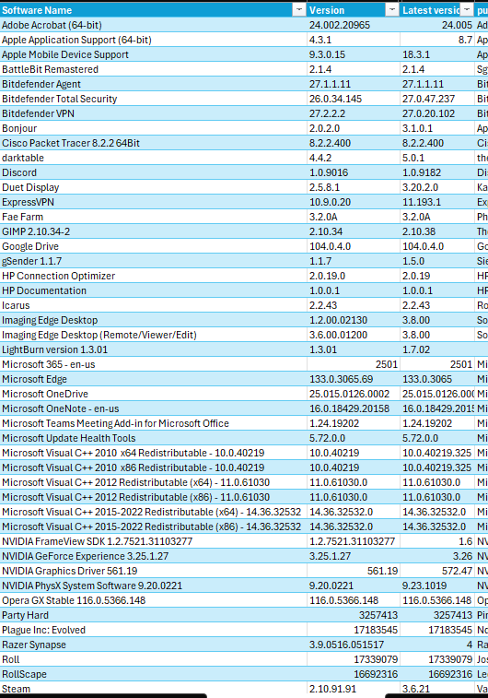
Old / newVersions for my personal system
- Research any vulnerabilities in the software or hardware
- Adobe Acrobat versions 24.002.20964 and earlier may have vulnerabilities that could allow for arbitrary code execution
- GeForce Experience version 3.25 contains vulnerabilities including an uncontrolled search path vulnerability in the installer which could allow attackers with user-level privileges to load arbitrary DLLs, potentially leading to privilege escalation and code execution; additionally, issues with the NVContainer component could enable users without admin privileges to create symbolic links, potentially causing denial of service or data tampering
- CVE-2021-30494
- Razer synapse 3.9.131 An attacker can create a file in an unintended directory by taking advantage of privileged operations performed by system services installed alongside Razer Synapse 3.
- Razer synapse 3.9.131 Attackers can exploit a race condition to replace a valid DLL with a malicious DLL. This allows local Windows users to gain administrative privileges on Windows.
- An issue exists in Valve Steam Client 2.10.91.91. The installer allows local users to gain NT AUTHORITY\SYSTEM privileges because some parts of %PROGRAMFILES(X86)%\Steam and/or %COMMONPROGRAMFILES(X86)%\Steam have weak permissions during a critical time window. An attacker can make this time window arbitrarily long by using opportunistic locks.
- Code Injection vulnerability in the web interface in McAfee Web Advisor (WA) prior to 4.1.1.48 allows remote unauthenticated attacker to allow the browser to render a website which Web Advisor would normally have blocked via a carefully crafted web site.
- Piriform, a subsidiary of Avast, has released a security notification for CCleaner version 5.34 for Windows 32-bit devices, and CCleaner Cloud version 1.07.3214. This update comes after it was discovered earlier versions of CCleaner were compromised to deliver malware to users.
- Classic Shell 4.3 was known to have vulnerabilities related to malicious file execution, particularly when downloading updates or installing the software, which could potentially allow attackers to inject harmful code into a user's system, potentially leading to data compromise or system takeover; this issue was highlighted when a contaminated version of Classic Shell was distributed, inadvertently impacting users who downloaded it.
- The version of Google Chrome installed on the remote Windows host is prior to 54.0.2840.99. It is, therefore, affected by the following vulnerabilities :
  - - A remote code execution vulnerability exists in the FFmpeg component due to an integer overflow condition in the mov_read_keys() function in mov.c caused by improper validation of user-supplied input. An unauthenticated, remote attacker can exploit this, by convincing a user to visit a website containing specially crafted content, to cause a denial of service condition or the execution of arbitrary code. (CVE-2016-5199)
  - - A denial of service vulnerability exists in the V8 component due to an out-of-bounds read error that is triggered when handling 'Math.sign'. An unauthenticated, remote attacker can exploit this, by convincing a user to visit a website containing specially crafted content, to crash the browser or disclose memory contents.
  - (CVE-2016-5200)
  - - An information disclosure vulnerability exists due to a flaw in the expose() function in utils.js. An unauthenticated, remote attacker can exploit this, by convincing a user to visit a website containing specially crafted content, to disclose sensitive internal class information. (CVE-2016-5201)
  - - An unspecified vulnerability exists in the PruneExpiredDevices() function in dial_registry.cc that allows an unauthenticated, remote attacker to have an unspecified impact. (CVE-2016-5202)
- Putty 0.67 - The remote host has a version of PuTTY installed that is prior to 0.67. It is, therefore, affected by a stack-based buffer overflow related to handling SCP-SINK file-size responses that could allow arbitrary code execution.
- 7-Zip through 18.01 on Windows implements the "Large memory pages" option by calling the LsaAddAccountRights function to add the SeLockMemoryPrivilege privilege to the user's account, which makes it easier for attackers to bypass intended access restrictions by using this privilege in the context of a sandboxed process. Note: This has been disputed by 3rd parties who argue this is a valid feature of Windows.
- Wireshark 1.6.7 - CVE-2013-3556 - The fragment_add_seq_common function in epan/reassemble.c in the ASN.1 BER dissector in Wireshark before r48943 has an incorrect pointer dereference during a comparison, which allows remote malicious users to cause a denial of service (application crash) via a malformed packet.
- Gzip 1.3.5
  - CVE-2009-2624 - The huft_build function in inflate.c in gzip prior to 1.3.13 creates a hufts (aka huffman) table that is too small, which allows remote malicious users to cause a denial of service (application crash or infinite loop) or possibly execute arbitrary code via a crafted archive. NOTE: this issue is caused by a CVE-2006-4334 regression.
  - CVE-2006-4336 -Buffer underflow in the build_tree function in unpack.c in gzip 1.3.5 allows context-dependent malicious users to execute arbitrary code via a crafted leaf count table that causes a write to a negative index.
  - CVE-2006-4337 - Buffer overflow in the make_table function in the LHZ component in gzip 1.3.5 allows context-dependent malicious users to execute arbitrary code via a crafted decoding table in a GZIP archive.
  - CVE-2006-4335 - Array index error in the make_table function in unlzh.c in the LZH decompression component in gzip 1.3.5, when running on certain platforms, allows context-dependent malicious users to cause a denial of service (crash) and possibly execute arbitrary code via a crafted GZIP archive that triggers an out-of-bounds write, aka a "stack modification vulnerability."
- Gimp 2.2.13 - CVE-2006-4519 - Multiple integer overflows in the image loader plug-ins in GIMP prior to 2.2.16 allow user-assisted remote malicious users to execute arbitrary code via crafted length values in (1) DICOM, (2) PNM, (3) PSD, (4) PSP, (5) Sun RAS, (6) XBM, and (7) XWD files.
- Rdesktop 1.5.0
  - CVE-2008-1803 - Integer signedness error in the xrealloc function (rdesktop.c) in RDesktop 1.5.0 allows remote malicious users to execute arbitrary code via unknown parameters that trigger a heap-based overflow. NOTE: the role of the channel_process function was not specified by the original researcher.
  - CVE-2008-1801 - An integer underflow vulnerability exists in the iso_recv_msg function (iso.c) of rdesktop 1.5.0. Remote attackers can exploit this by sending a Remote Desktop Protocol (RDP) request with a small length field. This can cause a denial of service (crash) and possibly allow the execution of arbitrary code.
  - CVE-2008-1802 - There is a buffer overflow vulnerability in the process_redirect_pdu function in rdesktop 1.5.0. This lets remote attackers run any code they want. They do this by sending a Remote Desktop Protocol (RDP) redirect request that has changed length fields.

